Chemist Warehouse

By

________

Level-6

Final Project

Table of Contents

Project Proposal 3

Goals and Objectives 3

Project Scope 3

Project Specifications 3

Target Audience 3

Project Deliverables 4

Resource Requirements 4

Project Tasks and Milestones 4

Project Assumptions 5

Project Report 5

Detail Design 6

Home Page 6

Signup Page 6

Signin Page 7

Add Category Admin View 7

Orders Admin View 8

My Cart Page View 8

Category Product  View 9

My Orders View 9

Project Testing 10

User Manual 10

Summary 10

System Configuration 10

User Access Levels 10

# 

# Project Proposal

## Goals and Objectives

The main goal or aim of the project is to implement an online web application named “Chemist Warehouse”. The main purpose of the web application provides an interface to user for purchasing the medicine at discounted price. Visitor can also maintain cart and place the order of items selected. In this application there are two types of users- admin and registered visitor. Admin has different functionalities as compare to registered visitor. Admin can add, edit, delete and check details of all medicine and related product available at chemist warehouse. Registered user can maintain their order and cancellation policy.

## Project Scope

The scope of this project is to implement an app named “Chemist Warehouse” with the help of which view the medicine and related details to cure themselves. The duration of the project is 20 working days which is equals to 4 weeks.

## Project Specifications

* Admin login/logout
* Add, edit, delete and check details of Categories by admin.
* Admin can delete, edit and check Medicine available online.
* Admin can view order details of user which place the Order online.
* Admin can register new admins.
* Registered Visitor can login/logout.
* New Visitor can register.
* Registered Visitor can control their Order placed online as well as cancel them.

## Target Audience

The target audience for this project is the people who want all their medicine and related things information online. The age can go from 18 plus to 100 plus.

## Project Deliverables

The deliverables of the project are:

|  |  |
| --- | --- |
| **Deliverable** | **Description** |
| Final Report | This will be the final report of the project. |
| Coding | The executable code of the project will go under this. |
| Documentation | This portrays the documentation of the project. |
| Testing | All the test details will be covered in this part. |

## Resource Requirements

* Windows Operating System.
* Microsoft word for documentation.
* Asp.net MVC Framework
* 64-bit Processor and 4 GB or more RAM
* Identity framework- ASP

## Project Tasks and Milestones

|  |  |  |  |  |
| --- | --- | --- | --- | --- |
| **Tasks** | **Week-1** | **Week-2** | **Week-3** | **Week-4** |
| Brainstorming and analysis |  |  |  |  |
| Planning and initial meeting Project Proposal document. |  |  |  |  |
| Database Design and UI Design |  |  |  |  |
| Identity framework implementation |  |  |  |  |
| Coding for admin and reporter |  |  |  |  |
| Testing |  |  |  |  |
| Final Documentation and closing |  |  |  |  |

## Project Assumptions

Following are the assumption made while implementing the project:

* One admin and registered visitor will be registered by default.
* Application will be free and open source.

# Project Report

#### Functional and Non-Functional

|  |  |
| --- | --- |
| Users | Functional |
| Admin | * Login/logout * Register new admins * Admin can add, edit, delete, check details for categories and sub categories of item. * Admin can edit, delete and check details for Item available store. * Admin can view personal details of user which place order online. |
| Customer | * Can view details of all items available online * Can control their order online and maintain his/her cart. * New customers can register for free. * Login using valid credentials |
|  | Non- Functional |
|  | * High speed * Fast Loading time * High performance and security * All browsers compatibility. |

## Detail Design

### Home Page

The main landing page of the application. On navigation bar options are- Home, Categories Link, Cart, Sign up, Sign in.

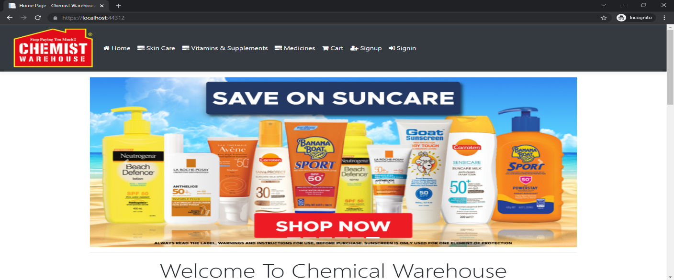

### Signup Page

With the help of this page, new visitor can register online

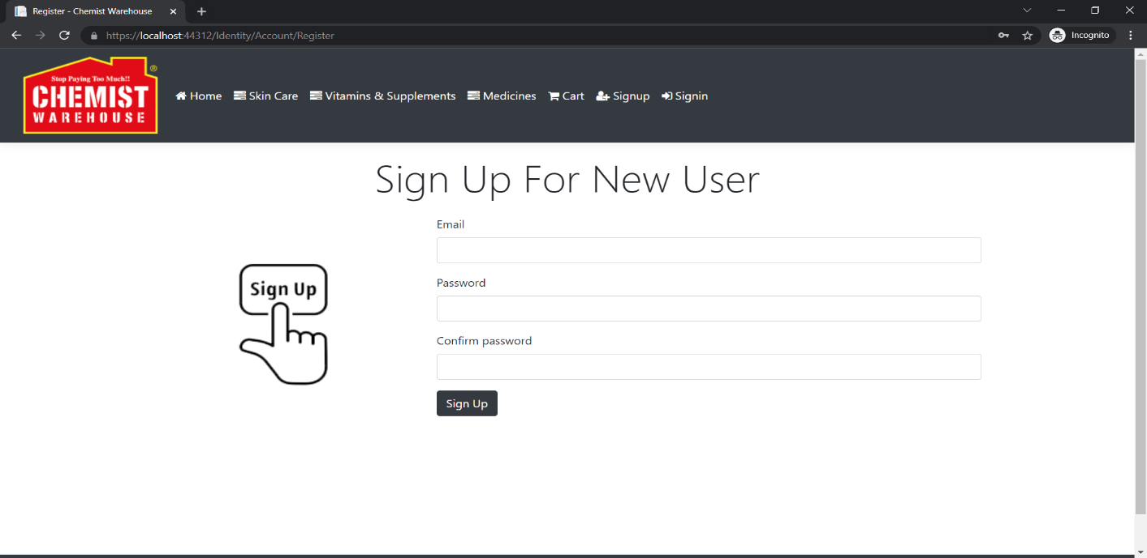

### Signin Page

With the help of this page, visitor can login to page and access unrestricted page.

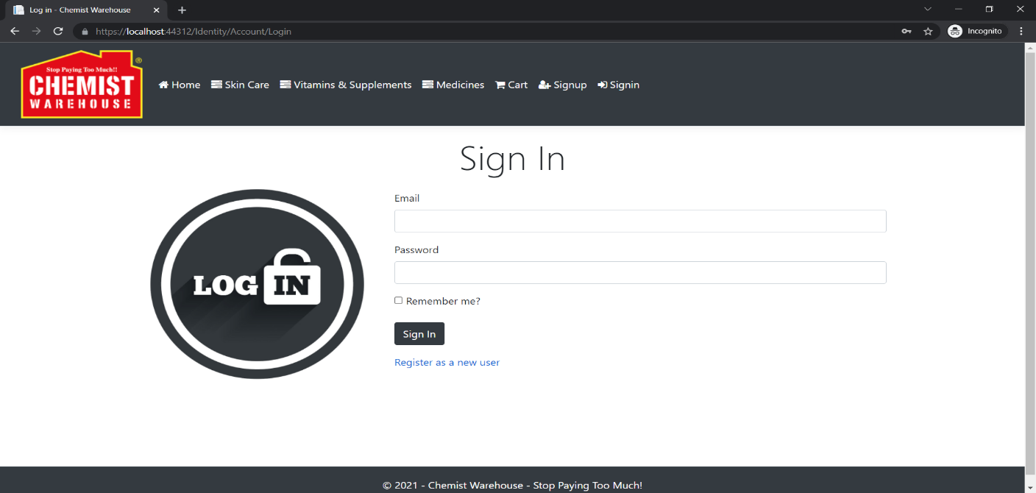

### Add Category Admin View

This page provide a way to add new category to Chemist Warehouse.

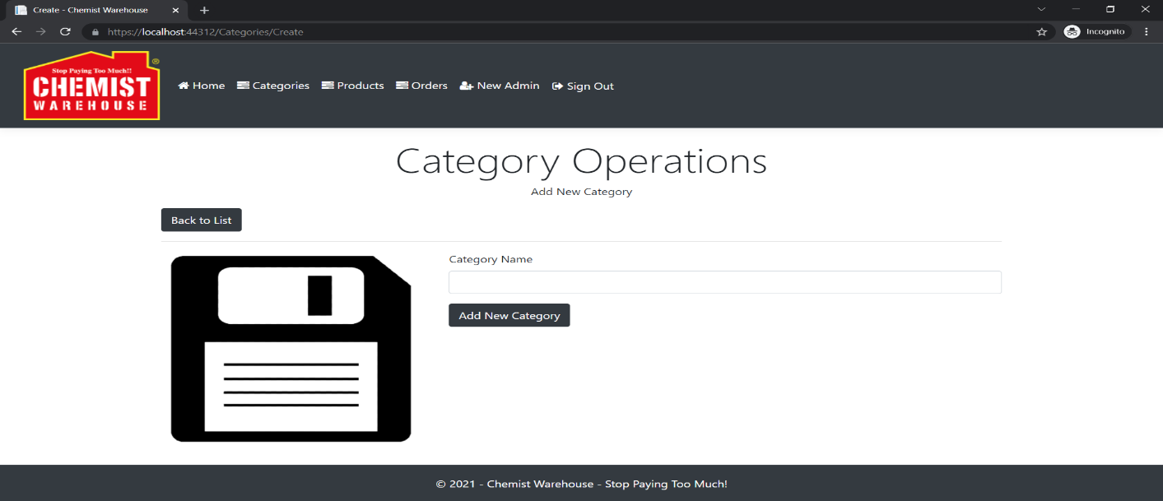

### Orders Admin View

With the help of this page admin can view personal details and link to order details of all order placed by registered user.

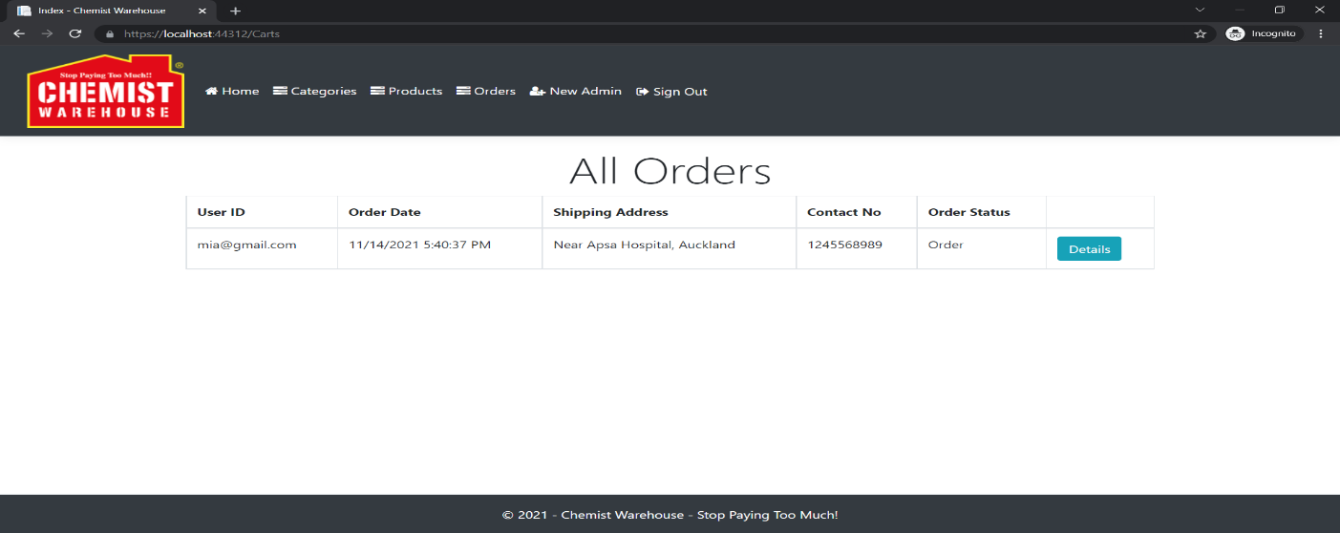

### My Cart Page View

With the help of this page Register user can view his/her cart details.

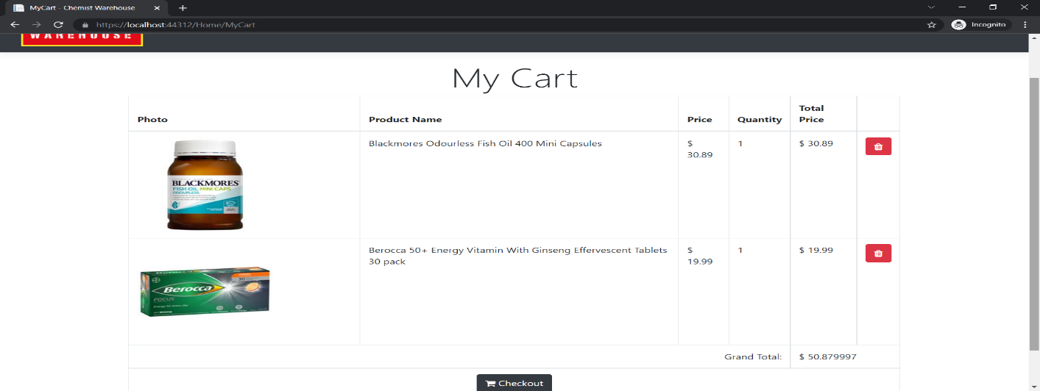

### Product Category View

With the help of this page visitor can view all medicine related to selected category.

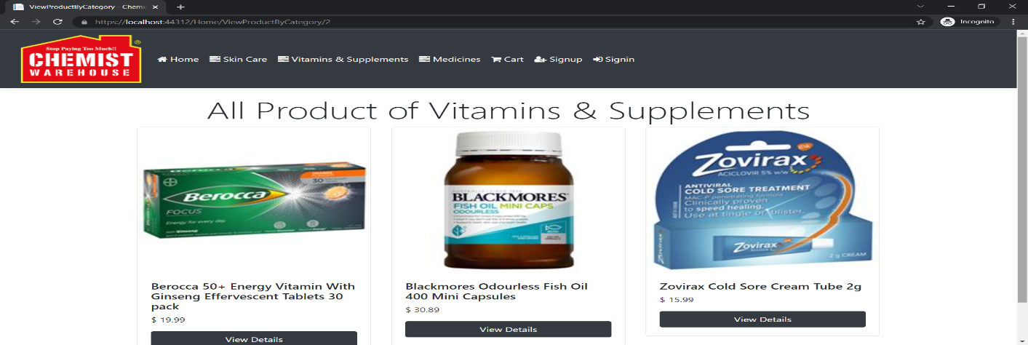

### My Orders View

This page shows the all order placed by registered user and way to cancel them.

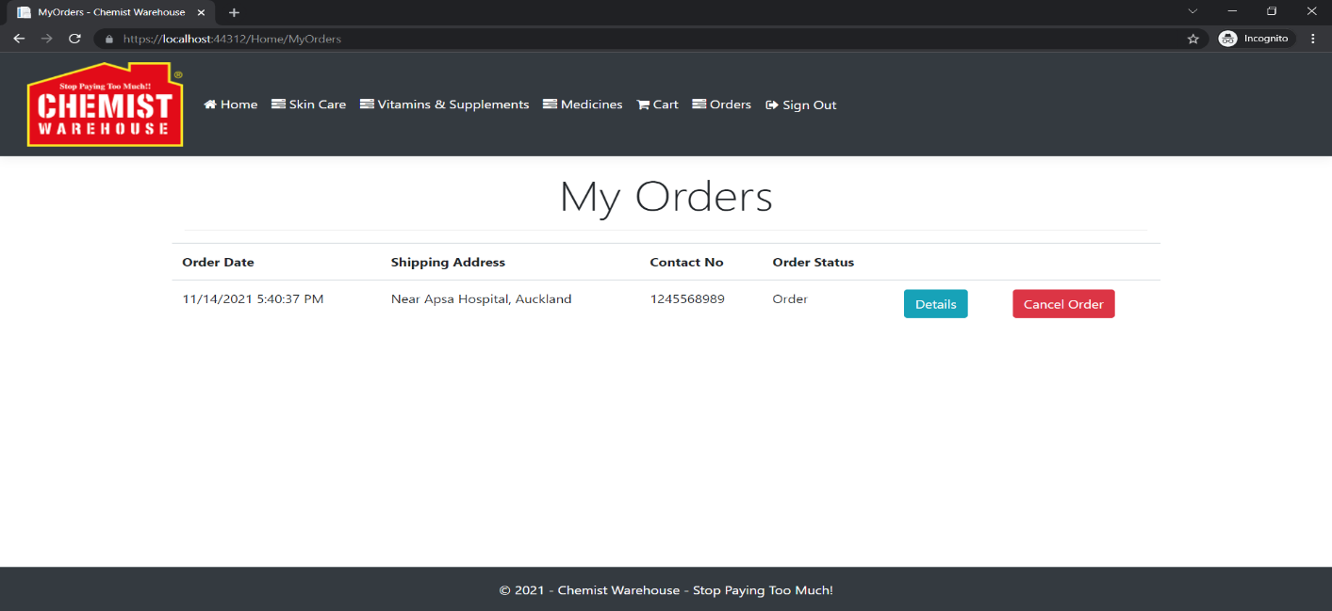

## Project Testing

The testing file for usability testing is attached as [usability test.xlsx](usability%20test.xlsx)

# User Manual

The main purpose of the application Chemist Warehouse is to help person to find their medicine and their details with a way to purchase them. In this application there are two types of users- admin and registered user or visitor. Admin has different functionalities as compare to registered user. Admin can perform all CRUD operation on data available on Chemist Warehouse. Registered User is capable to maintain his/her cart, place order as well as their cancellation.

## Summary

### System Configuration

This app will be useful to for distributing mobile information in presentable format.

### User Access Levels

Only registered users can access the features of this application.

* **Admin:** Admin has full access of the app can register new admins.
* **Registered Visitor:** New visitor can register and existing can login using their own credentials. They have limited access.